

**Web Development Fundamentals Project**

**CMPS 350 L51**

**Spring 2024**

**Dr. Mucahid Kutlu**

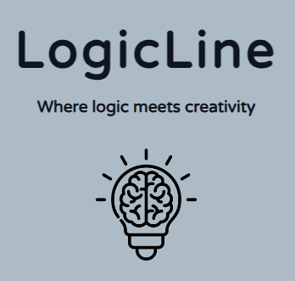

|  |  |  |
| --- | --- | --- |
| Student Name | QID | Email |
| Yosra Elshayeb | 201907974 | ye1907974@qu.edu.qa |
| Nashwa AlShamasi | 201901556 | na190556@qu.edu.qa |

**Project GitHub Link:**

**Project objectives:**

The main objective of this project is to utilize the knowledge and skills acquired in the CMPS350 course to create an E-commerce platform. This platform will facilitate the buying and selling of items, as well as provide users with the ability to track their transaction history, which will record all activities carried out on the platform.

1. **Design the APP Web UI & Navigation:**
2. **UI wireframe (sketch) to decide the UI components.**

Initially, we began brainstorming the front-end design of the platform based on the specified requirements.

**Requirements**:

The project involves the development of an E-commerce platform accommodating three distinct user roles:

* **Customers**: Individuals interested in purchasing items.
* **Sellers**: Entities seeking to sell items.
* **Admin**: Responsible for overseeing and managing the platform.

Each user type possesses **unique features** and functionalities:

* **Customers** are identified by their name, surname, shipping address, username, password, and monetary balance.
* **Sellers** are characterized by their company name, username, password, and bank account information.
* **Admins** are identified by their username and password credentials.

The platform features a main page serving as the initial interface for users upon visiting. On this page, users can search for items, but the ability to make purchases is restricted to logged-in users. Our E-commerce platform is called Logic Line, and it offers a variety of electronic products.

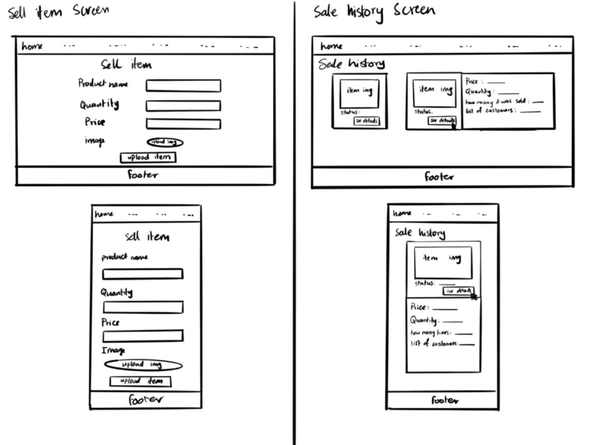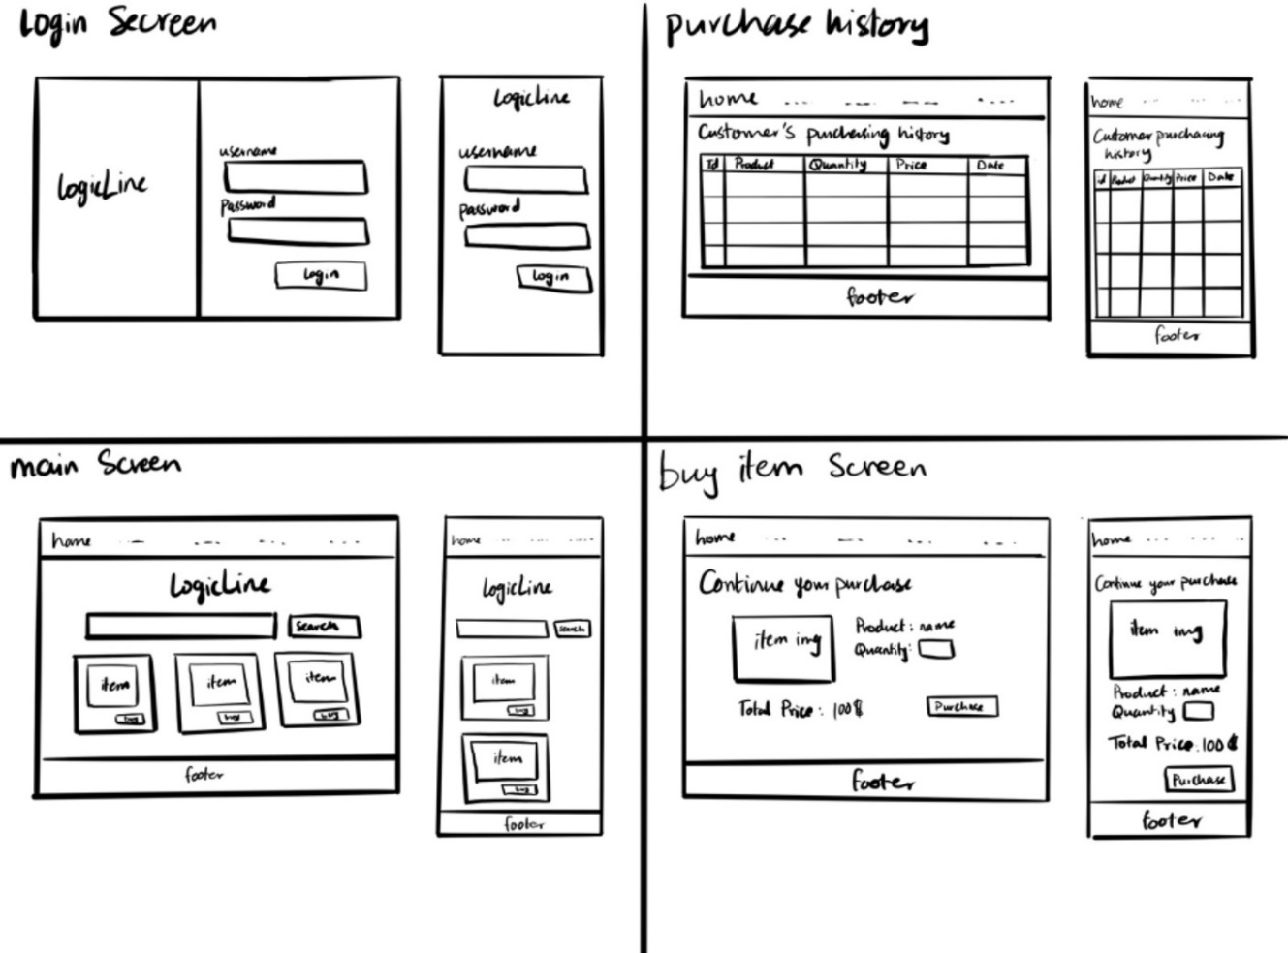

**Figure 1: UI Sketches**

1. **For each use case, implement the app UI and navigation using HTML, CSS, and JavaScript.**

Demonstrated in demo video.

1. **Each page should be responsive to support at least 2 layouts, one for mobile and another for PC.**

Screenshots for responsiveness:

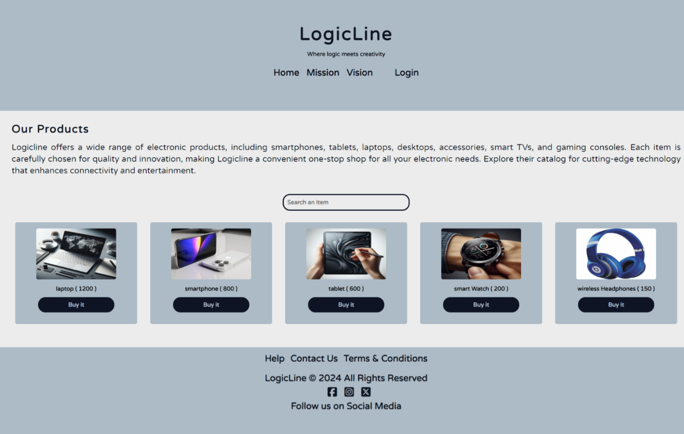

**Figure 2: Main Page Big Screen**

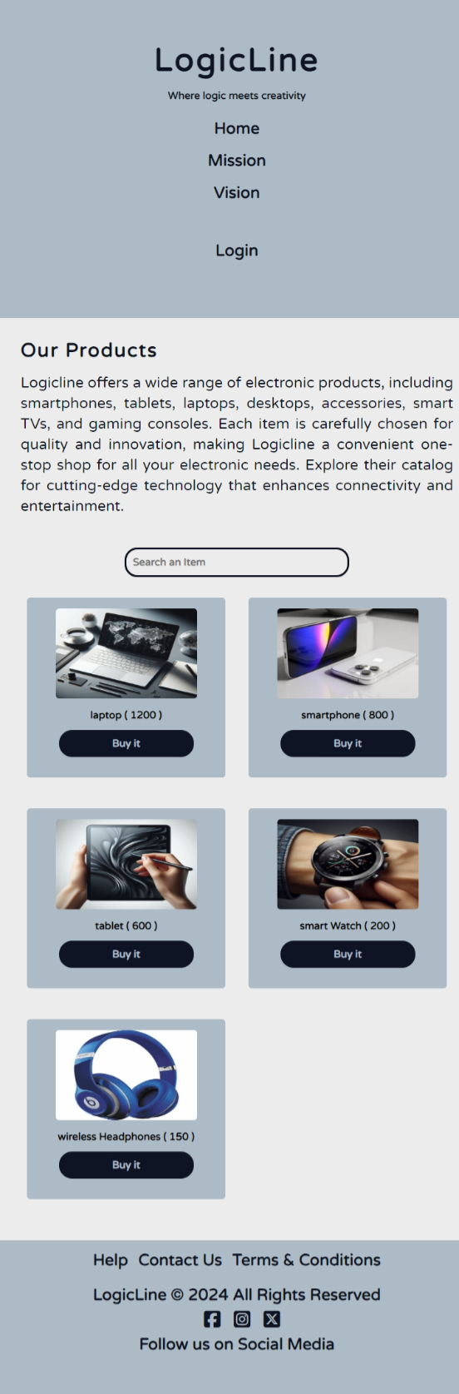

**Figure 3: Main-page Small Screen**

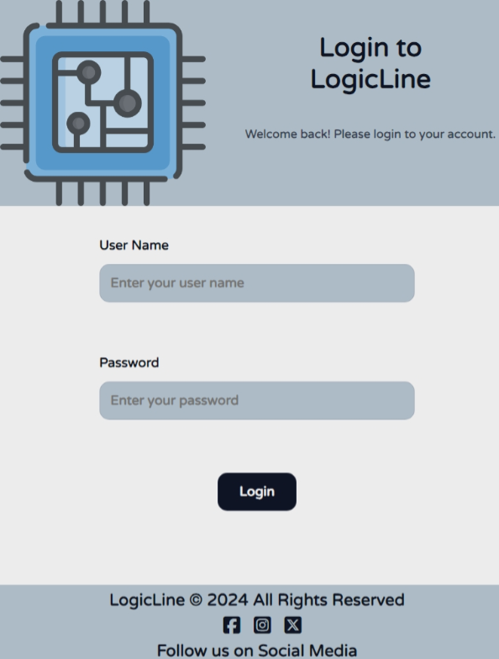

**Figure 4: Login Small Screen**

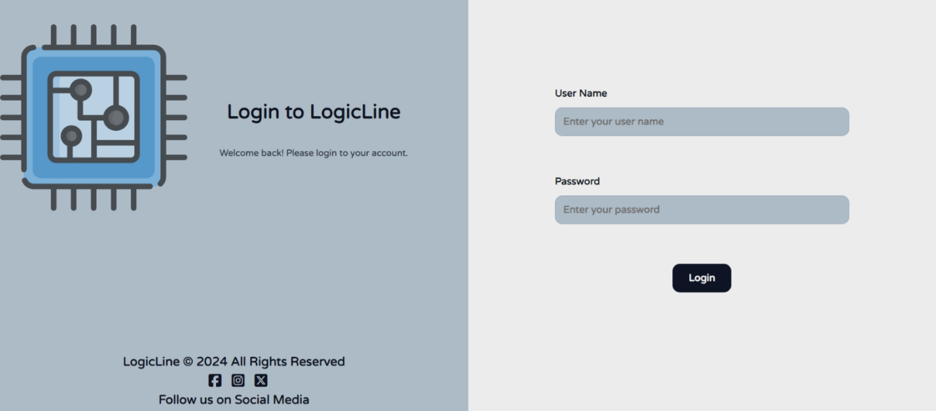

**Figure 5: Login Big Screen**

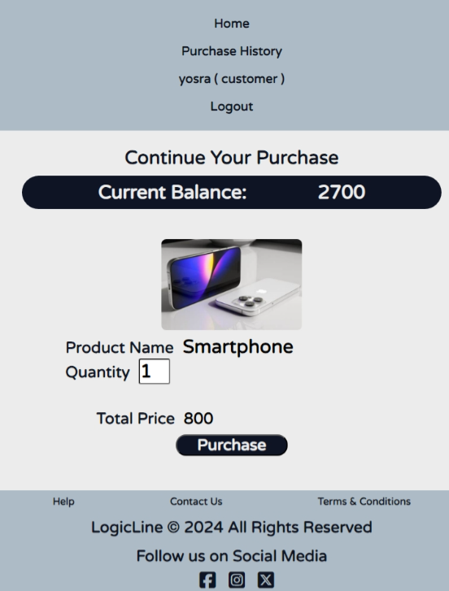

**Figure 6: Buy-item Small Screen**

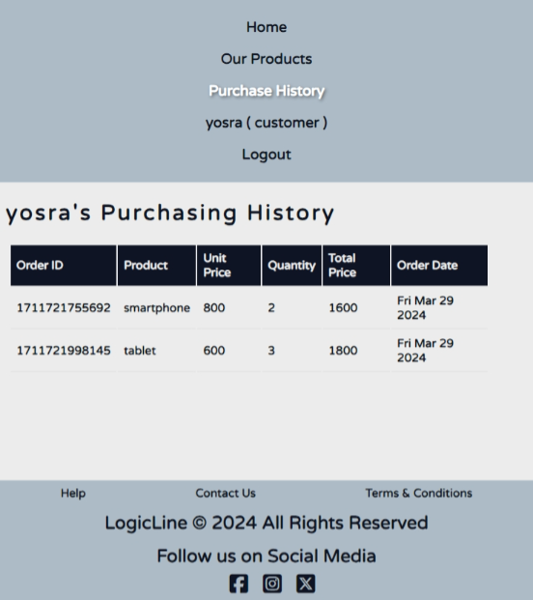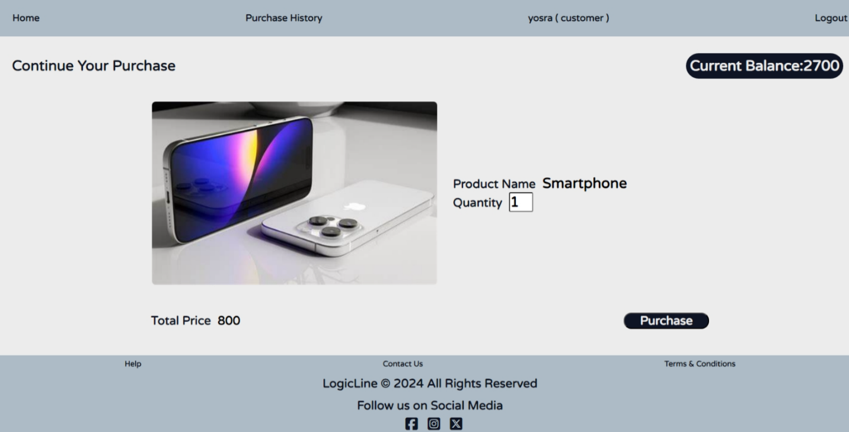

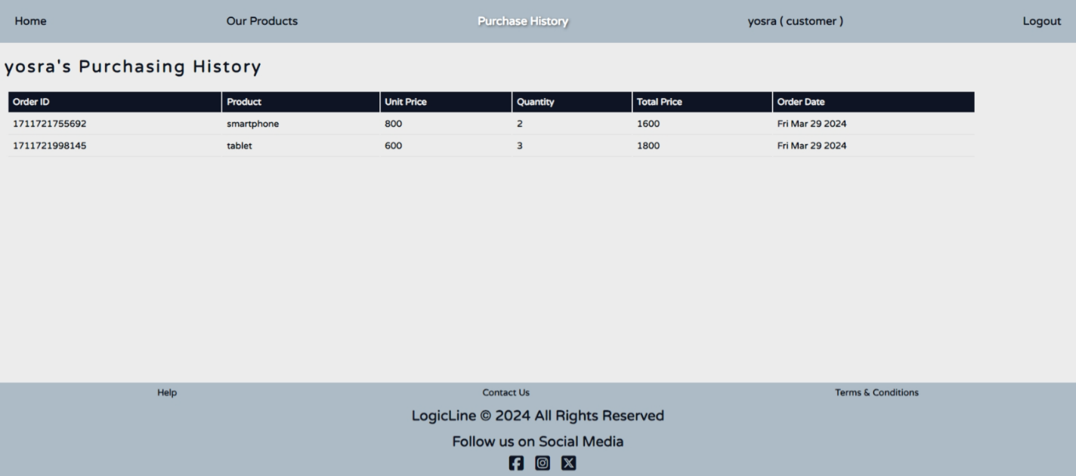



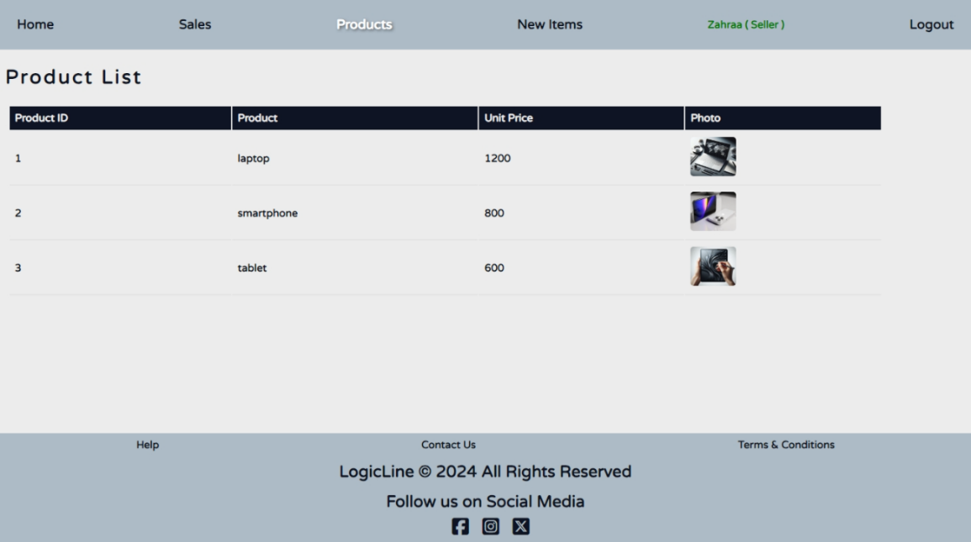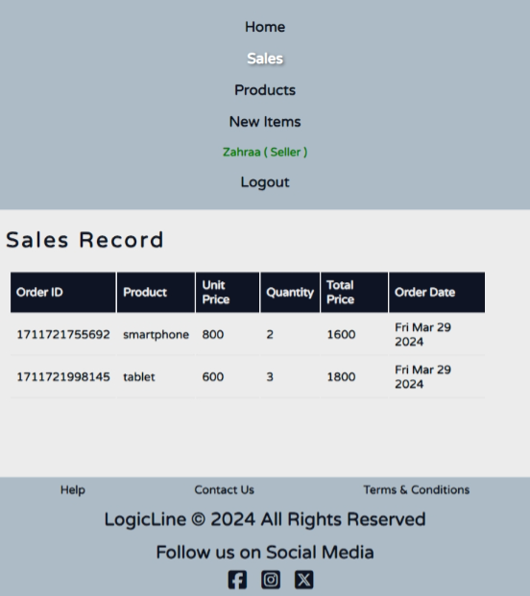

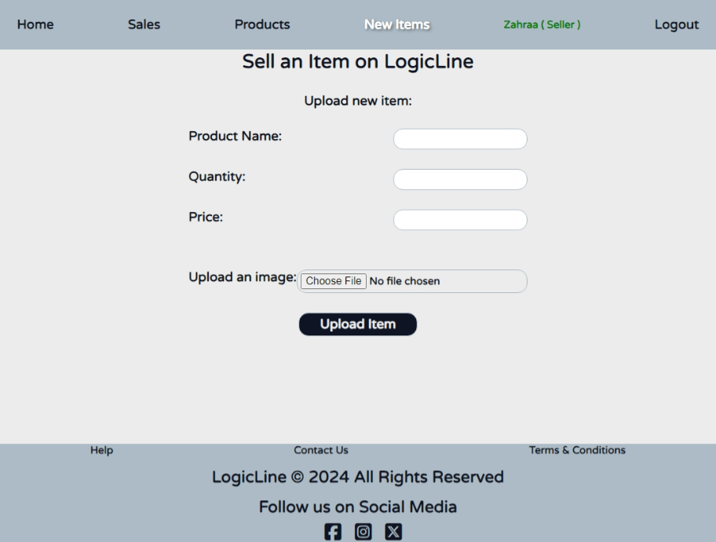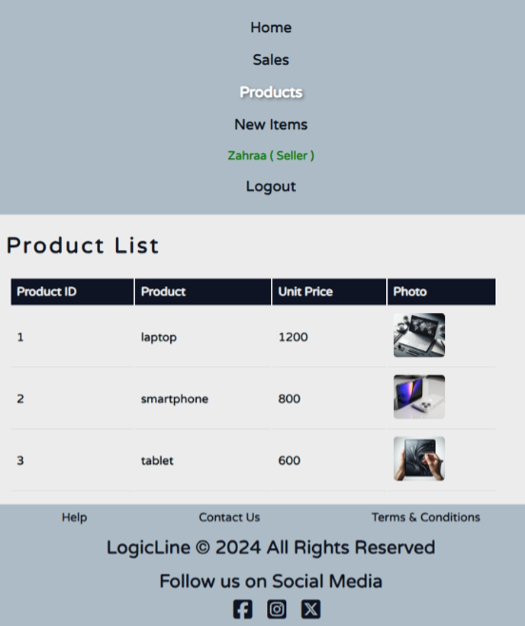

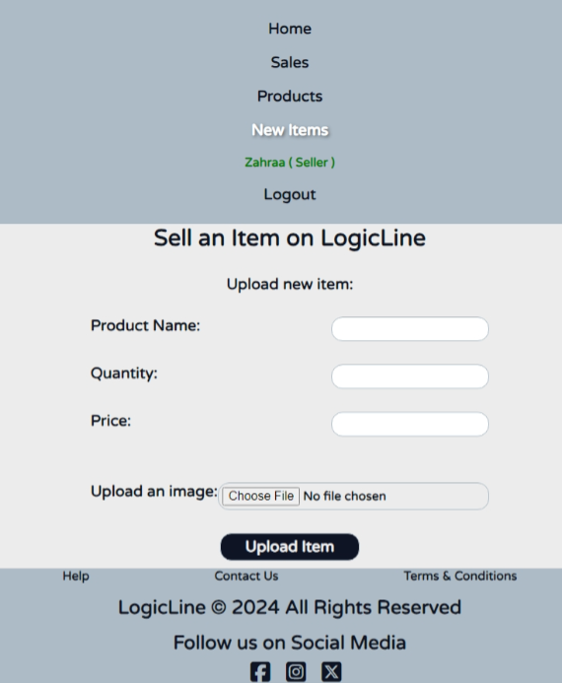

1. **Design and implement the app navigation to allow the user to navigate from one page to another in intuitive and user-friendly way to achieve the app use cases.**

Demonstrated in demo video.

1. **For phase 1, read/write simple JSON files that you need to create and initialize with some *sample* data.**

Demonstrated in demo video.

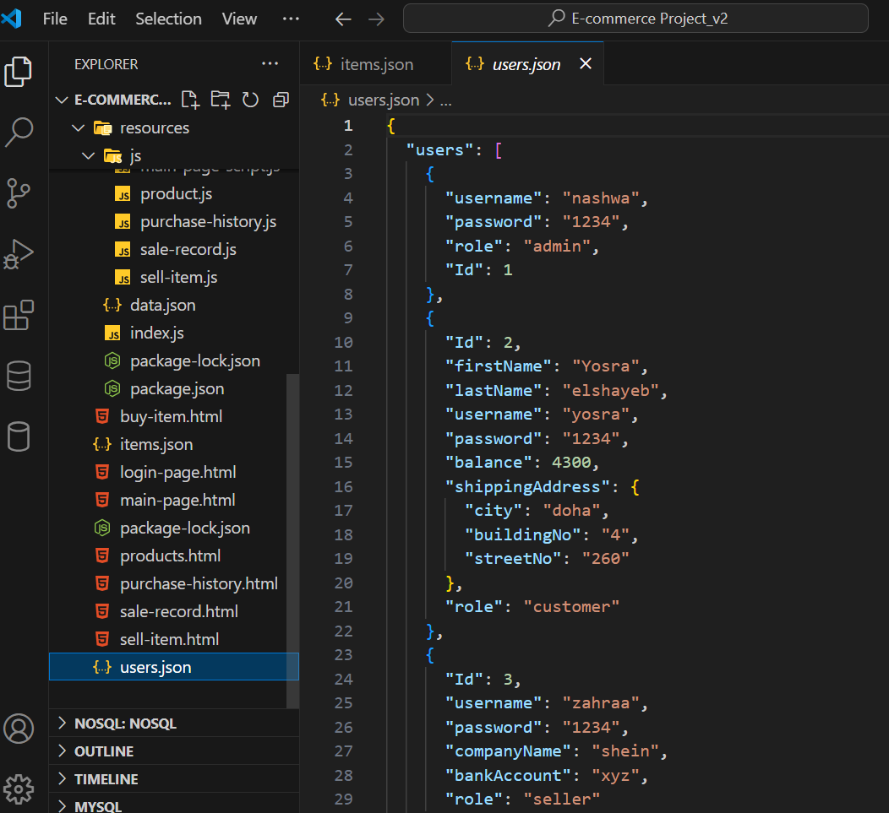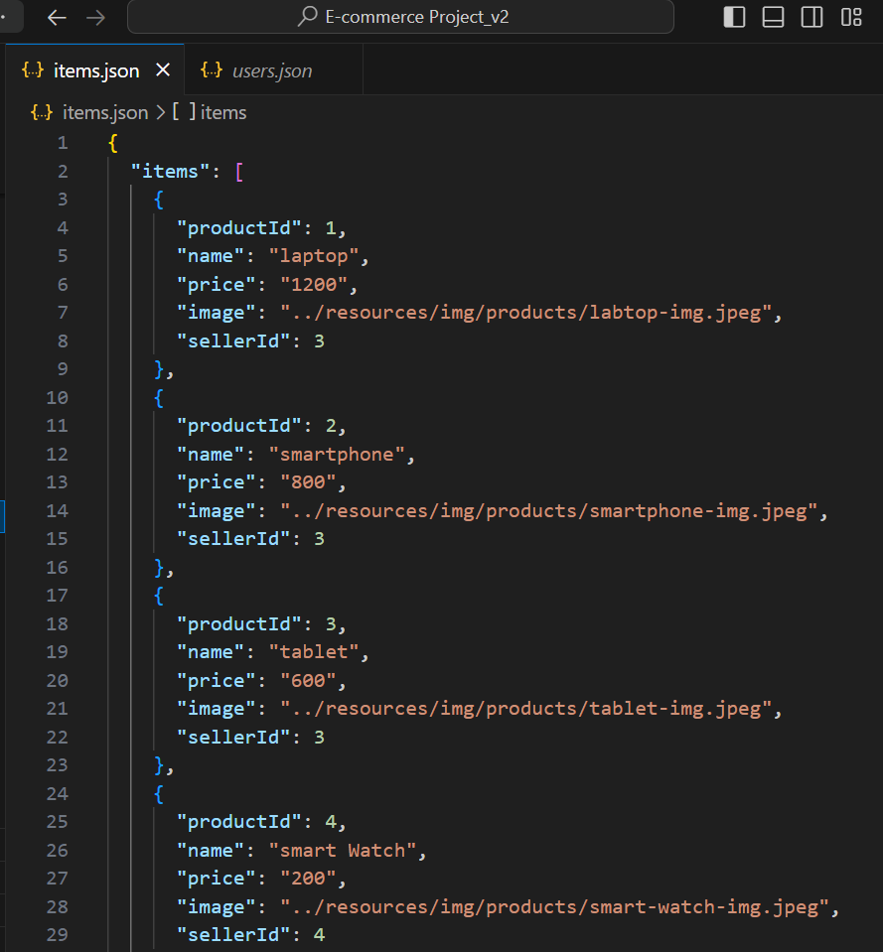

1. **Application design documentation should include the Entities, Repositories and Web API class diagrams**.
   1. **Repositories Class diagrams**.

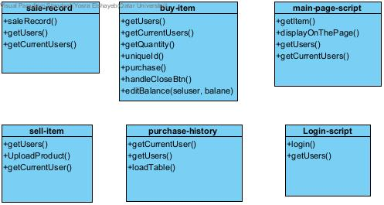

* 1. 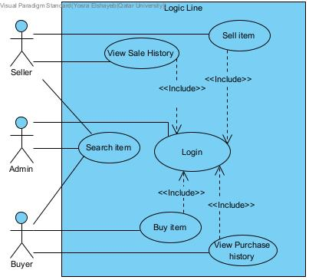**System Use Case Diagram**

1. **App testing:**
   1. **Screenshots & Explanation**

To run the website, we need first to right click at **resources** file and then choose open with **integrated terminal.**

>> Then Run these 2 commands.

* + npm install
  + node index

Then run **main-page.html** using live server.

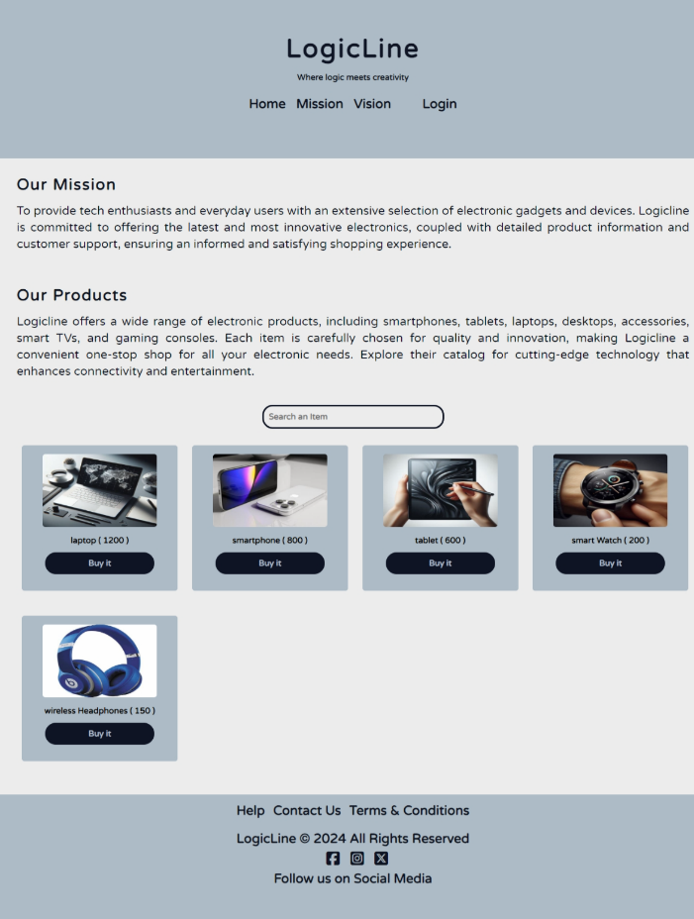

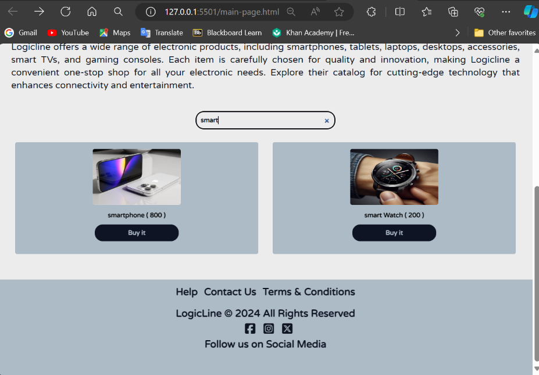This is the main page, once you click on home/mission/ vision their corresponding section will appear in the page but initially all you can see is the Products displayed in main page and search functionality.

You can search for any product stored in the system even if you’re not logged in. However, once you click on the buy it button you cannot proceed to the buy-item page without first logging in to the system using your credentials (Assuming you already have an account).

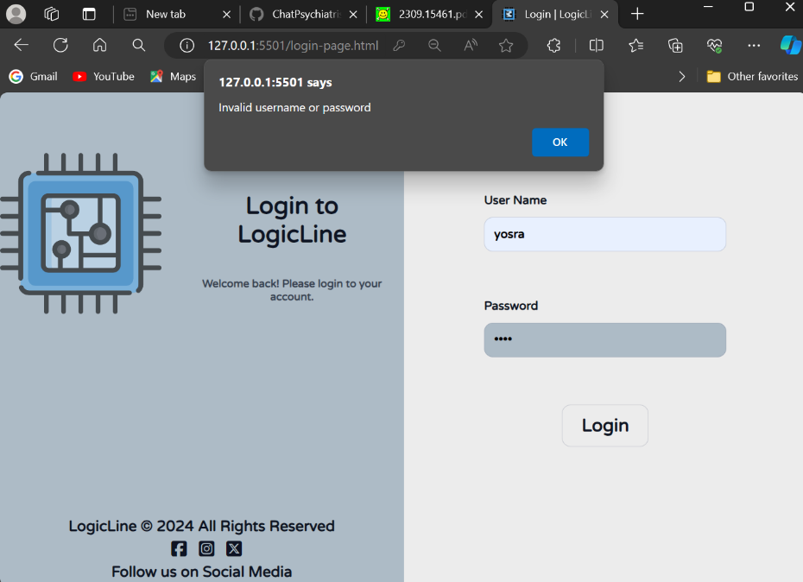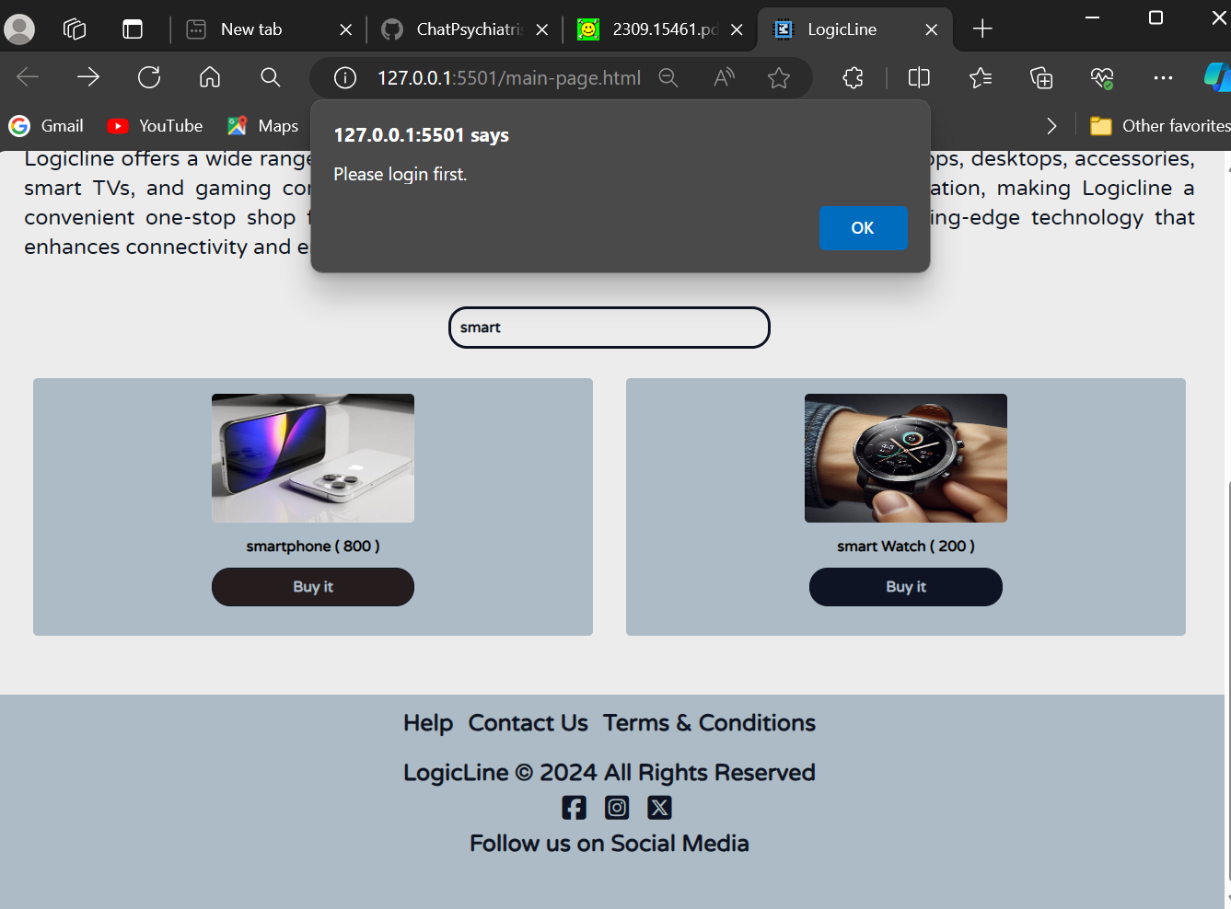This alert will pop up and once you click ok 🡺 you will be navigated to login.html page where you can enter your registered username and password.

If you enter an invalid username or password this alert will pop up and you need to try again.

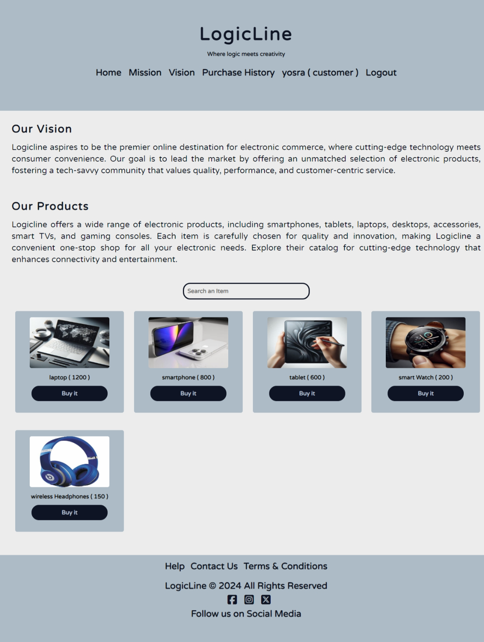Each user registered in the system is assigned a role (admin/seller/customer) for making this platform simple we assume that each user has one role only, so a seller cannot be a customer and buy items.

In the above figure the user is registered as a customer (role labels are created for demonstration purposes but in real-life these labels don’t exist)

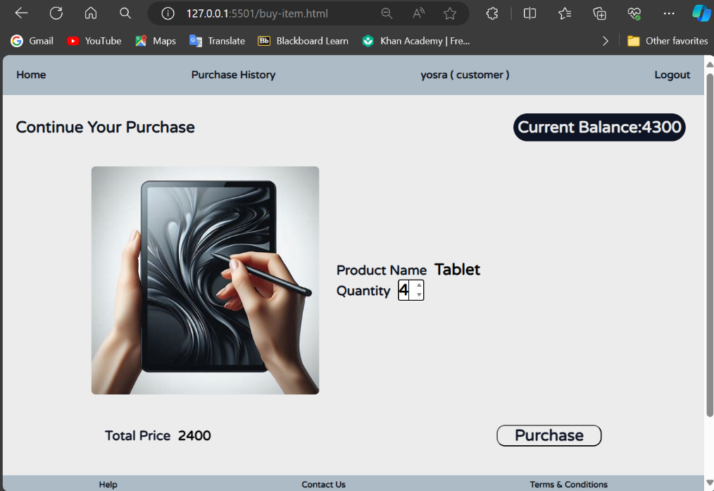The navigation bar is slightly different than the initial main page giving the customer another view (dashboard) where he can search for items and buy them. Also he can view his purchase history.

For example, here the customer clicked on “**buy it**” button underneath the tablet item displayed in the main page since he is logged in, he will be directly navigated to buy-item where he can proceed with the purchase of that item.

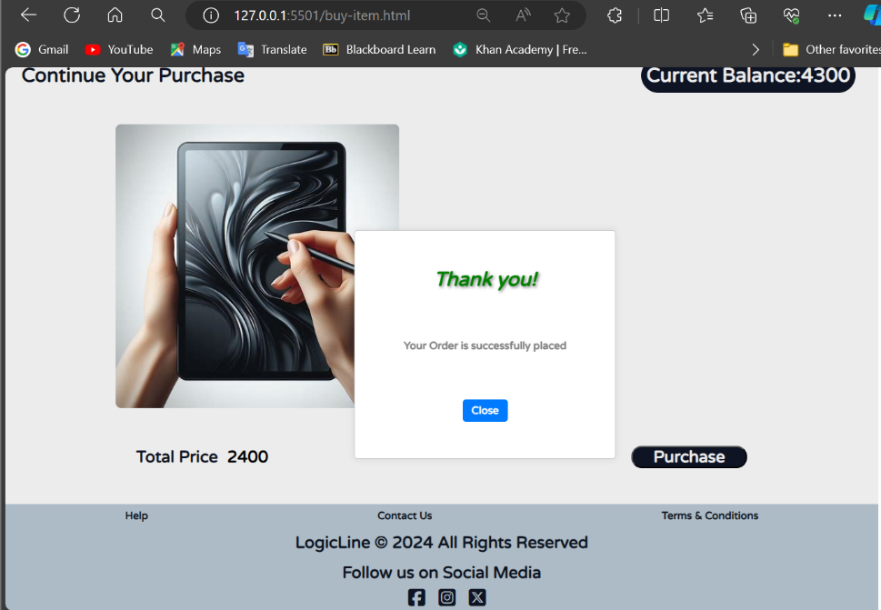Initially he can see the product name, select a quantity and the total price will be computed accordingly. Then he clicks on purchase and the purchase will be successfully placed.

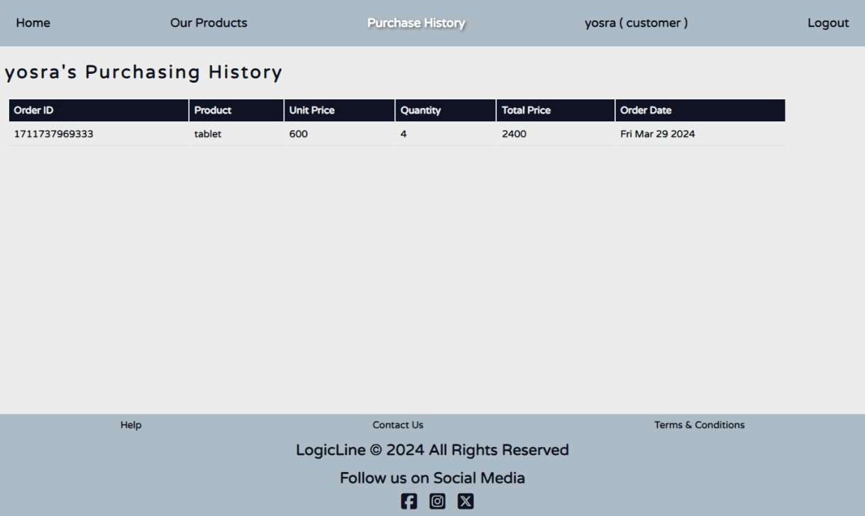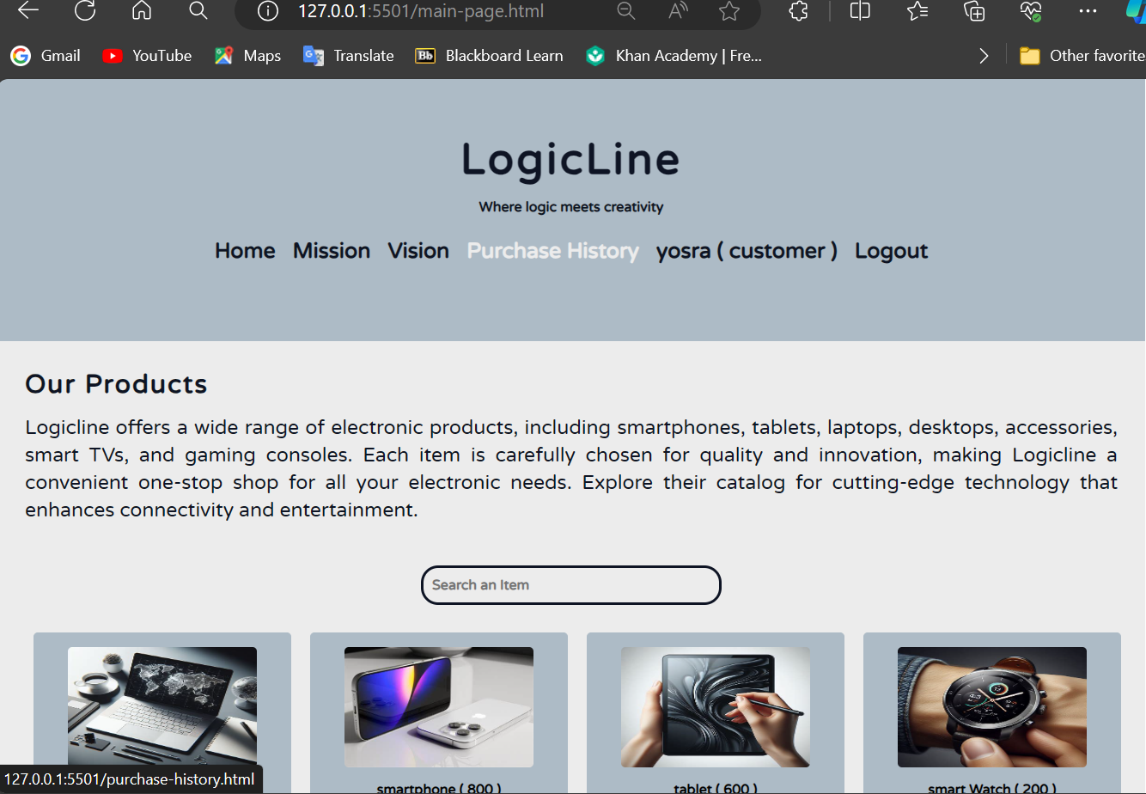After that the customer clicks close and he will be redirected to his dashboard, where he can click on “purchase history” and check the purchase he just made.

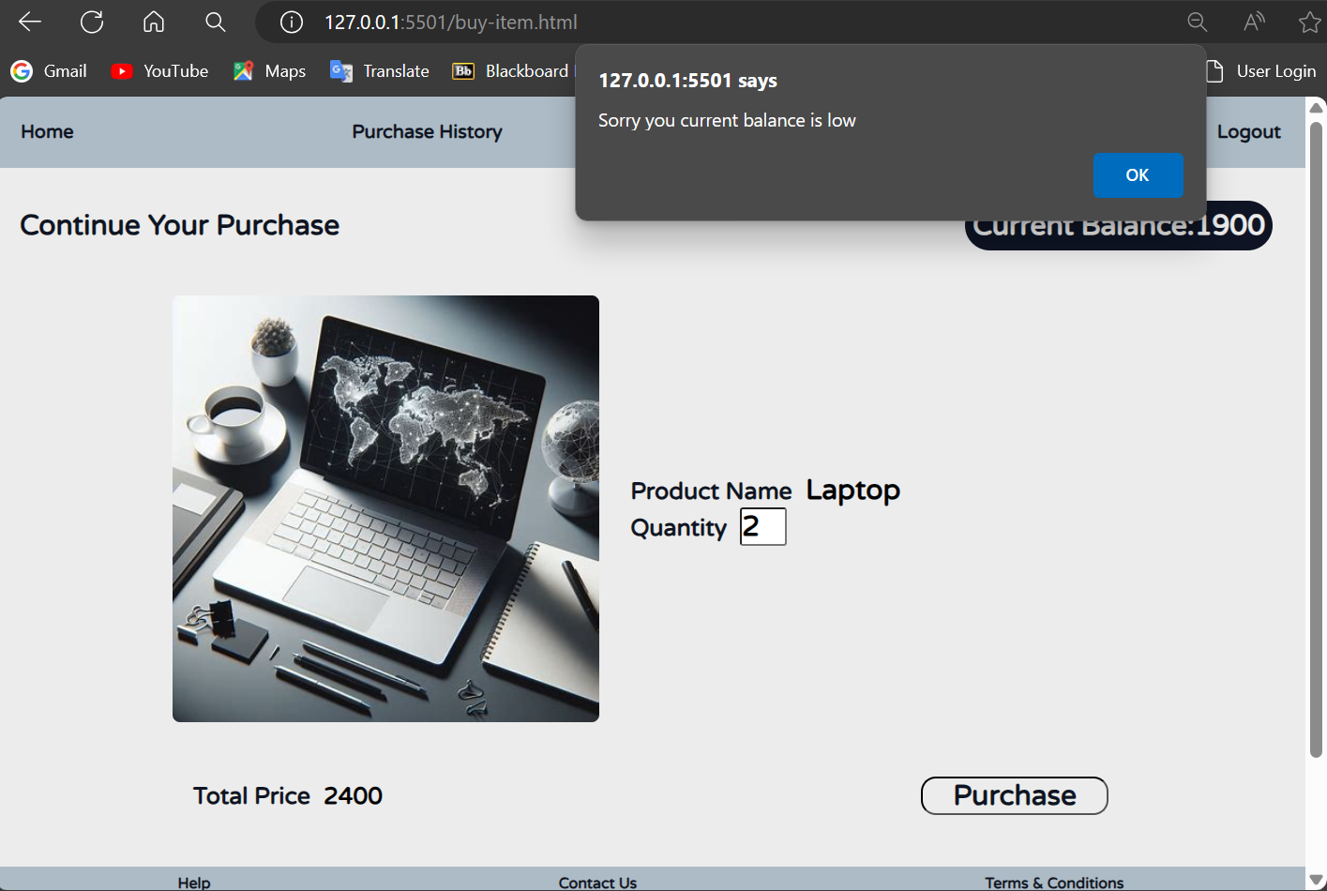When the balance is lower than the total price of the current purchase this pop-up alert will appear and the payment will not proceed.

All purchases will be documented in purchase history page.

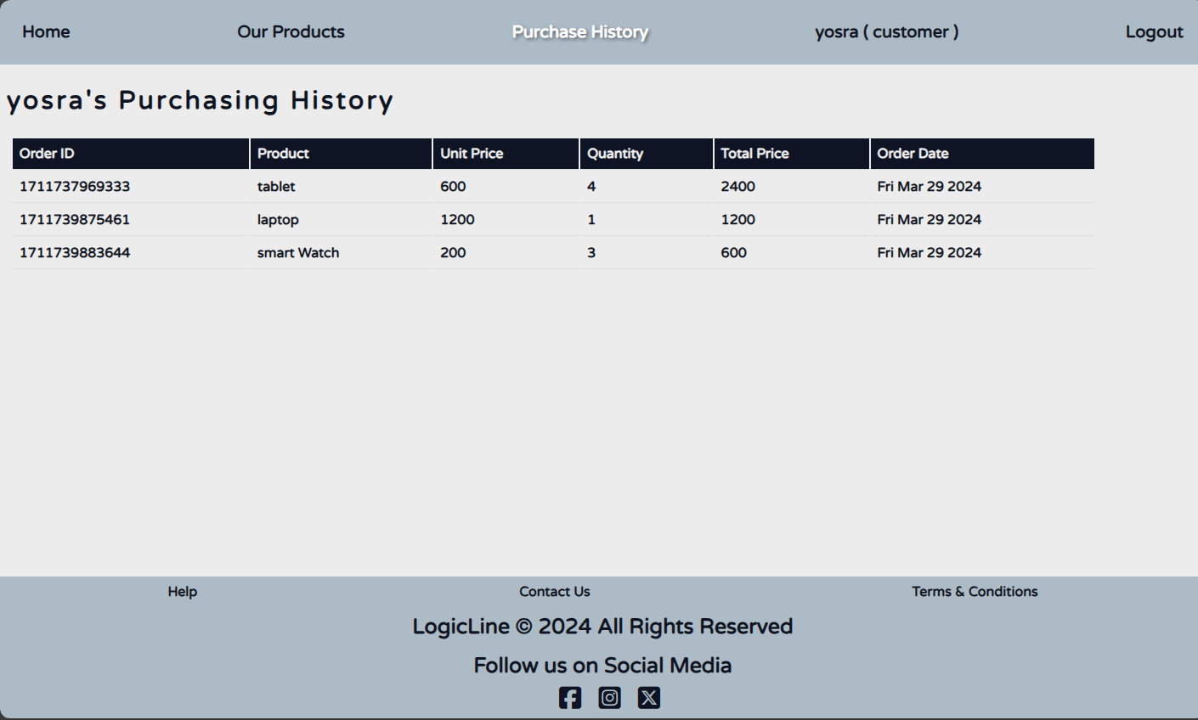

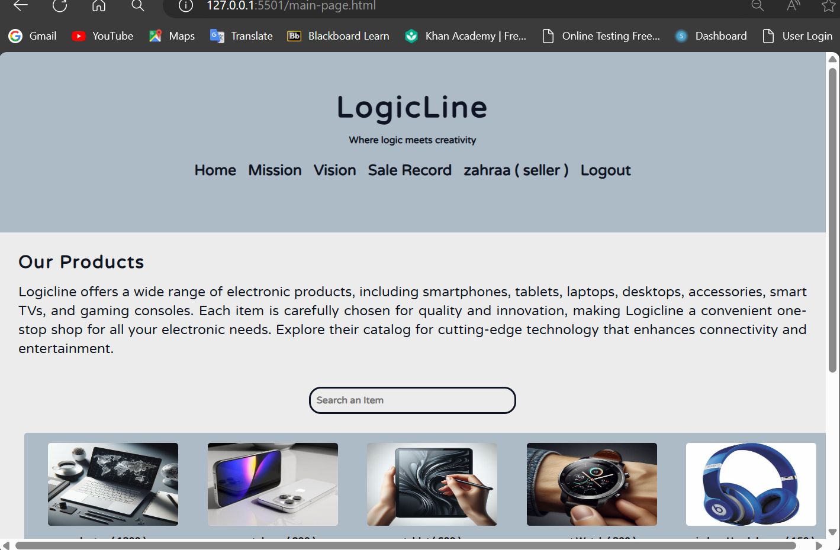Logged in as seller:

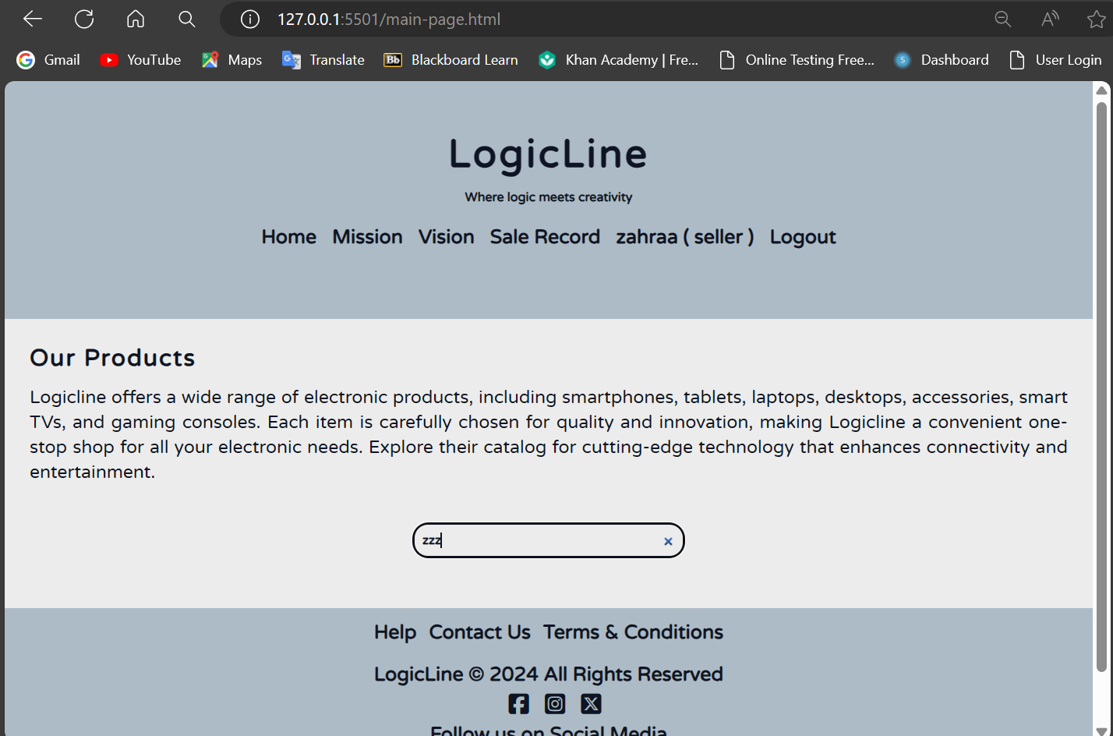A seller cannot buy any products, but he can search available items for sale, this case of searching an item that doesn’t exist.

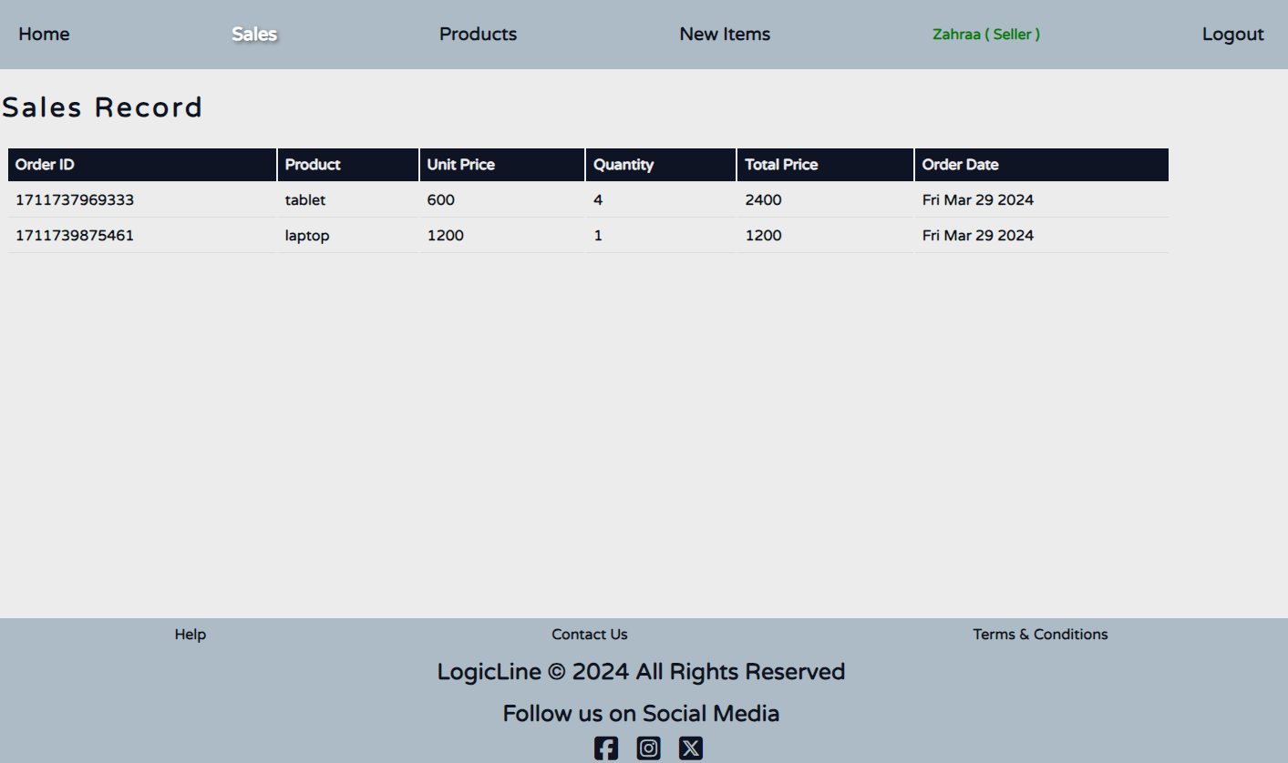Once the seller clicks on Sale Record he will be navigated to his dashboard.

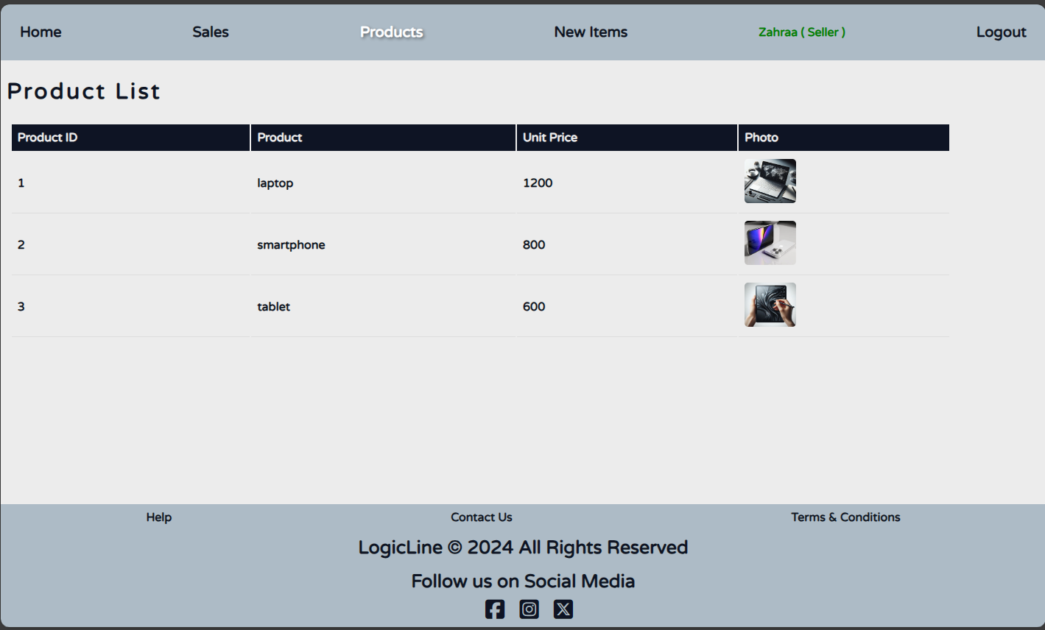Initially the sales record page will be displayed. Showing all sales done, and once he clicks on “Products”, he will see the Product list which is all products he had previously uploaded for sale.

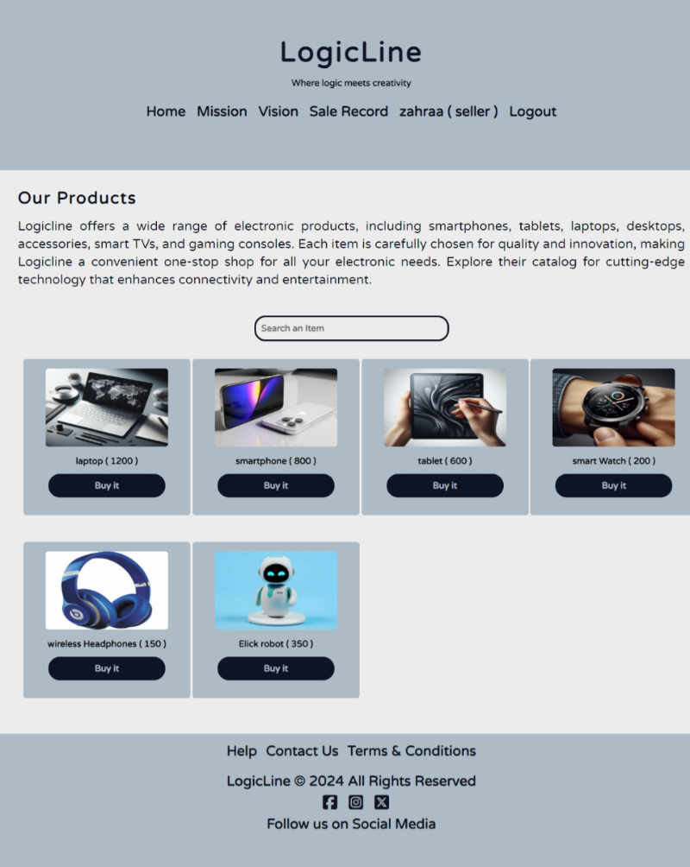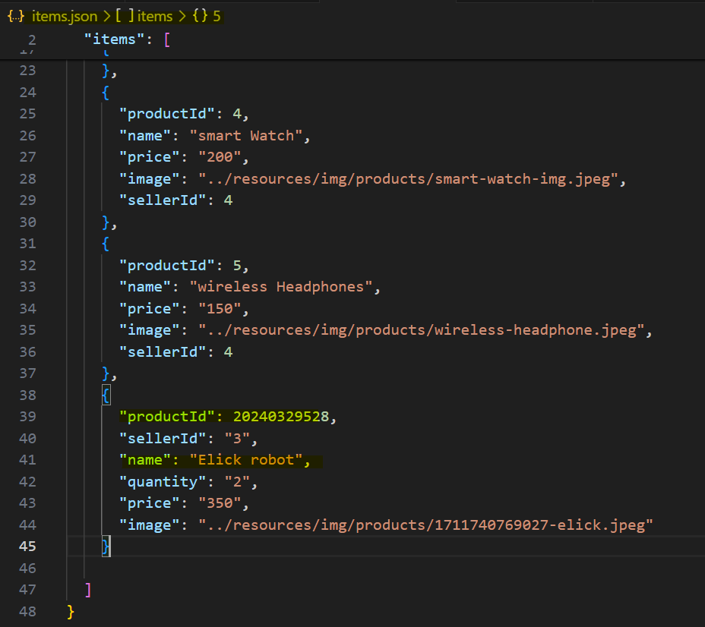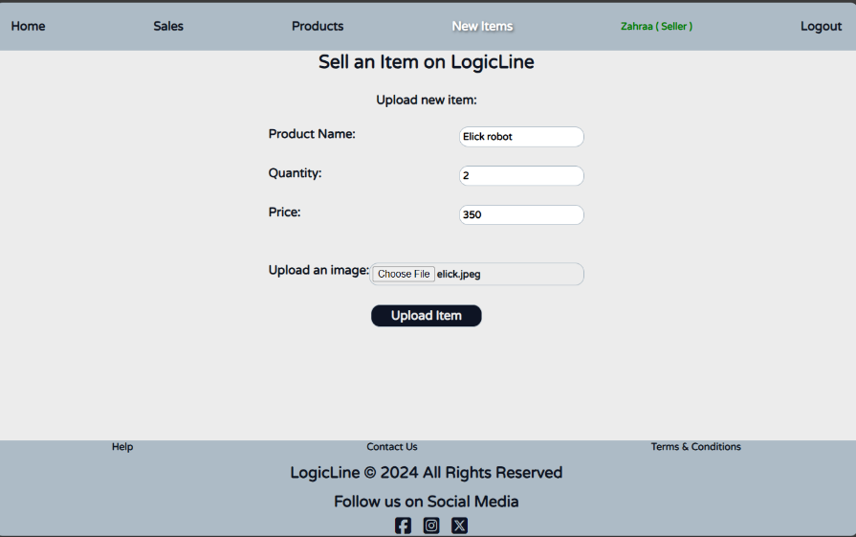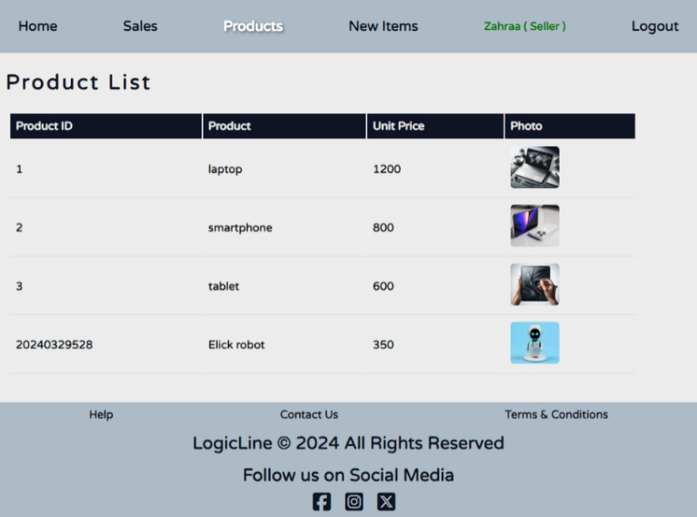Here is the demonstration of sell-item all new items will be added to Product list and will be available for sale in the products section in main-page and internally it will be saved in <items.json> file.

**Conclusion:**